**Supplementary Requirement Release 2**

1. Connectivity

**Scope:**

* UC01.01 Register new customer user
* UC01.02 View Account Details
* UC01.03 User Login
* UC01.04 Admin Login
* UC01.05 Create Admin Account
* UC01.06 Update Admin Account Details
* UC01.07 Update User Account Details
* UC01.08 Reset Password
* UC02.01 Add/Delete Menu Item
* UC02.02 Edit Menu Item Cost/Description
* UC03.01 View Menu
* UC03.03 Add/Remove item(s) to Cart
* UC03.04 View Past Orders
* UC03.05 Reorder Food
* UC03.06 Modify Order
* UC03.07 Display items/total price in cart
* UC03.10 Order received
* UC03.11 Search Menu Item
* UC03.12 Accept/Reject order
* UC03.13 Add to favourites
* UC03.15 Choose pickup time
* UC04.02 Use Rewards
* UC04.03 Accept Rewards
* UC05.01 Add credit/debit card
* UC05.02 Choose Pay online/in person
* UC05.03 Payment Complete
* UC05.04 Validate payment with stripe

Requirements:

* System should retain caches to populate values, if the front-end is disconnected due to Network issue.
* System should also show a popup window with an error message, “Connection failed, please try again later”.

**Conditions to Apply:** Around the respective join points.

1. Data Driven Validation

**Scope:**

* UC02.01 Add/Delete Menu Item

Requirements:

* If DB doesn’t contain all the items provided in the menu the user cannot Add/Delete an item.
* If DB does contain all the items provided in the menu the user MUST be able to Add/Delete an item

**Conditions to Apply:** After the respective join points.

1. Data Flow Out

**Scope:**

* UC 02.01 Add/Delete Menu Item

Requirements:

* After viewing the menu and choosing an item, if DB doesn’t contain all the items provided in the menu the user cannot Add/Delete an item.
* After viewing the menu and choosing an item, If DB does contain all the items provided in the menu the user MUST be able to Add/Delete an item

**Conditions to Apply:** After the respective join points.

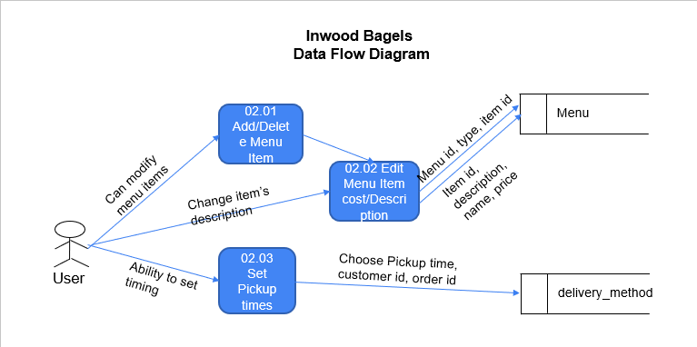

1. Data Flow In

**Scope:**

* UC03.11 Search Menu Item

Requirements:

* After viewing the menu and trying to choose an item, if DB doesn’t contain all the items provided in the menu the user cannot search for an item.
* After viewing the menu and trying to choose an item, If DB does contain all the items provided in the menu the user MUST be able to search for an item.

**Conditions to Apply:** Before the respective join points.

